**Exp. 6 Virtualization by installing type 2 Hypervisor**

**Aim:**

To demonstrate virtualization by Installing Type-2 Hypervisor in your device, create and configure VM image with a Host Operating system using virtual box.

**Procedure:**

* Open virtual box application
* Then click on new button to create a new VM
* Enter the name and select the required ISO file
* Enter credentials like username and password
* Select required hard disk size and memory size, along with number of CPUs
* Now the VM is created

**Output:**

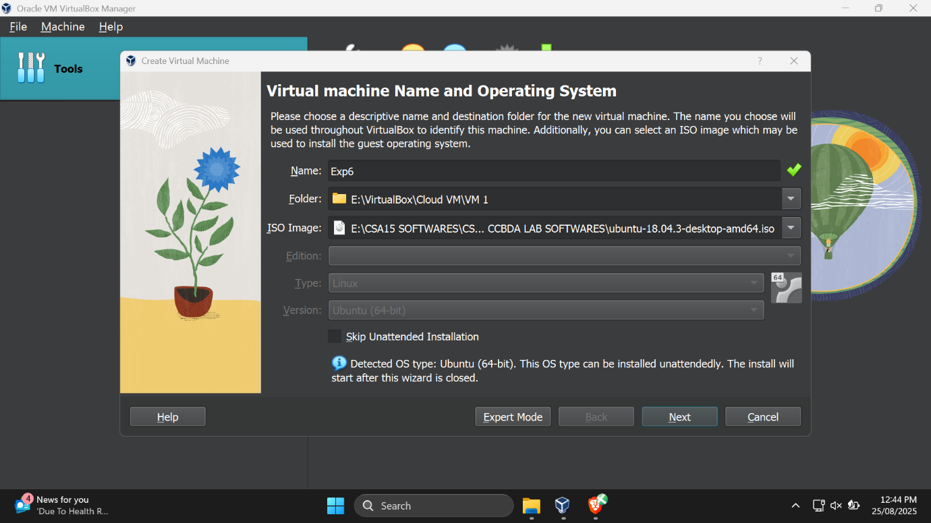

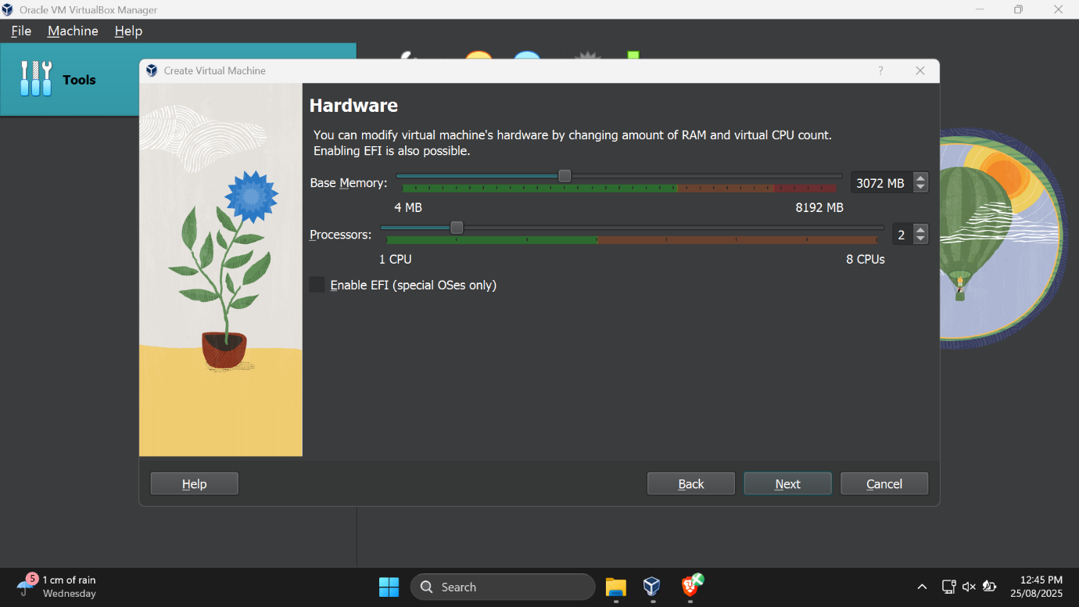

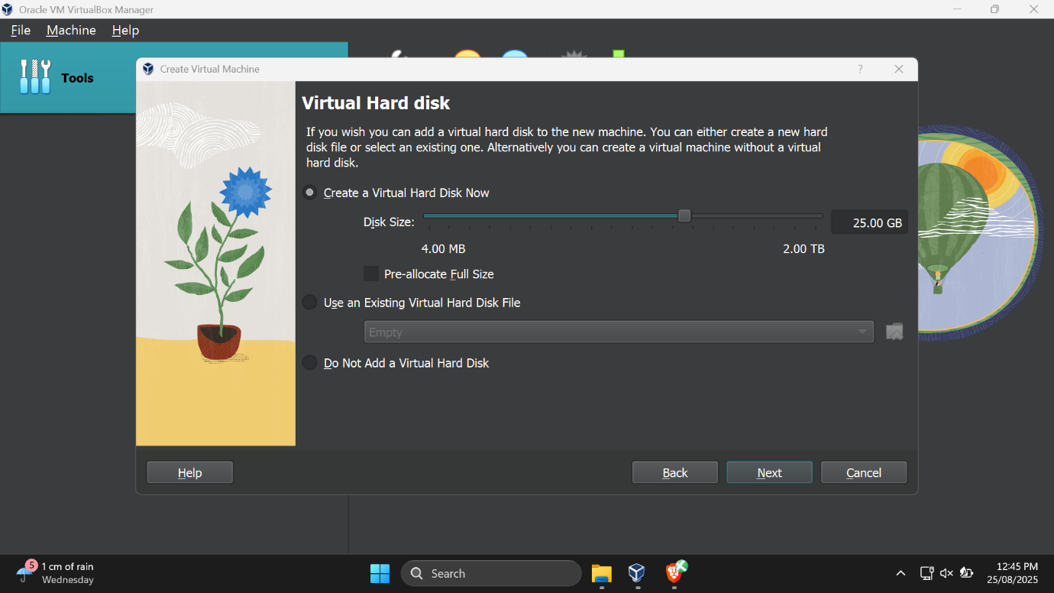

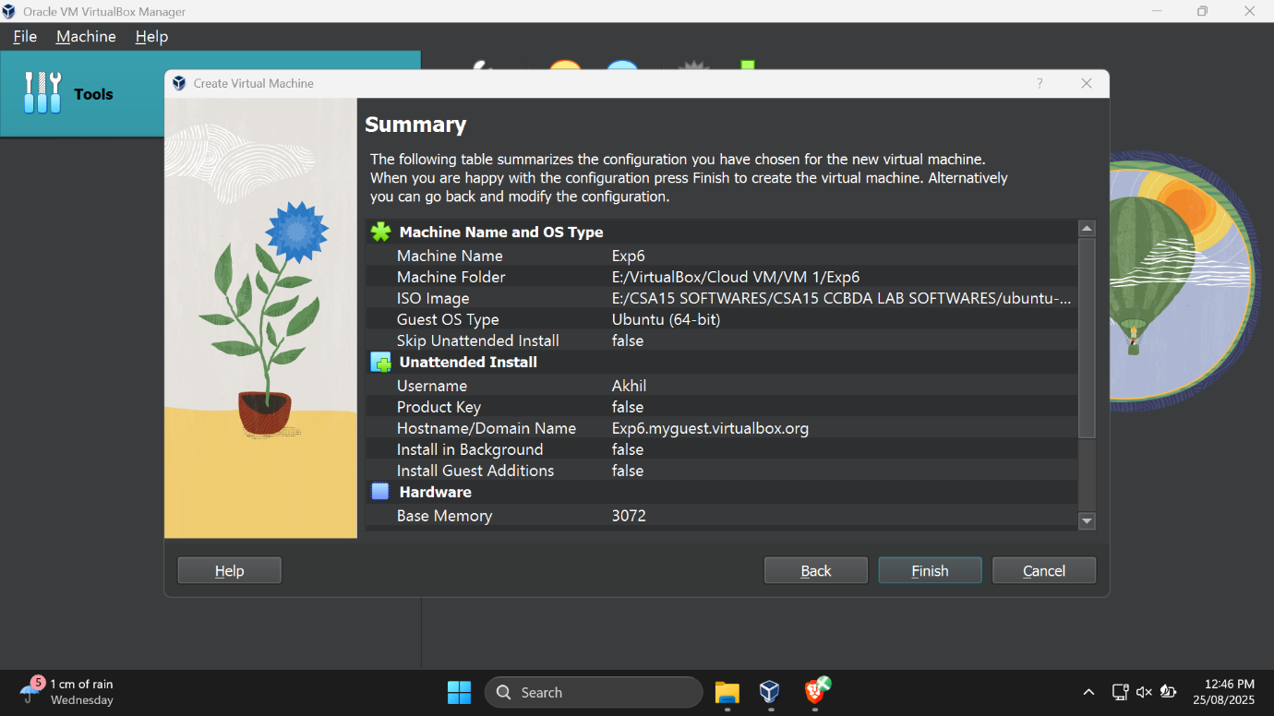

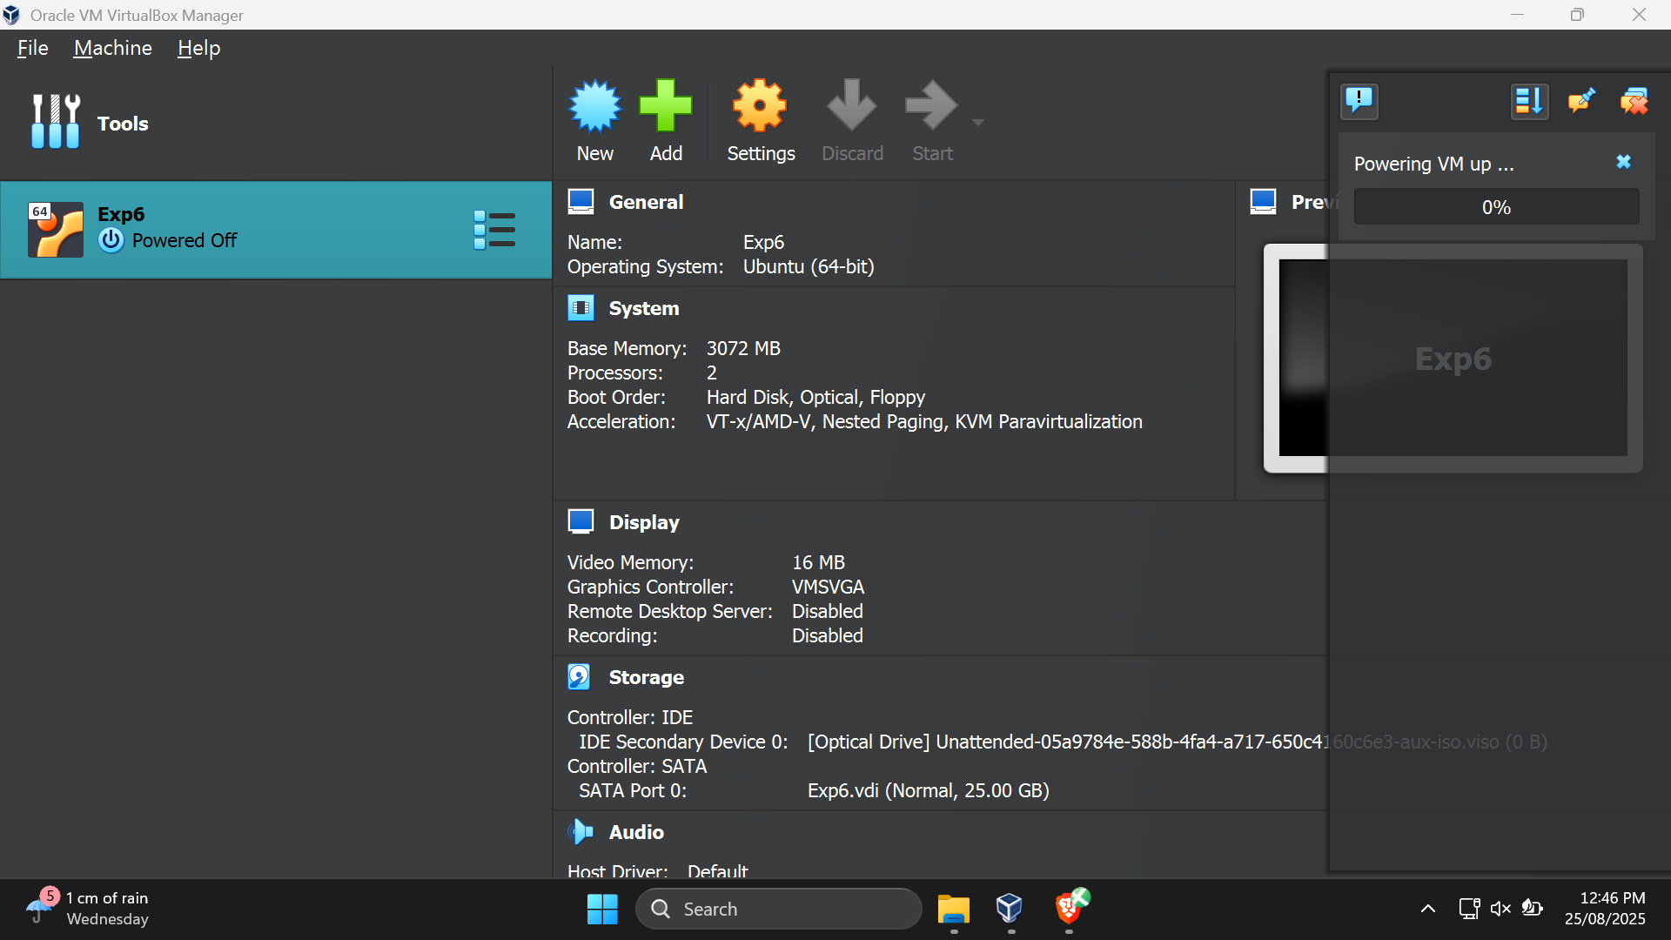

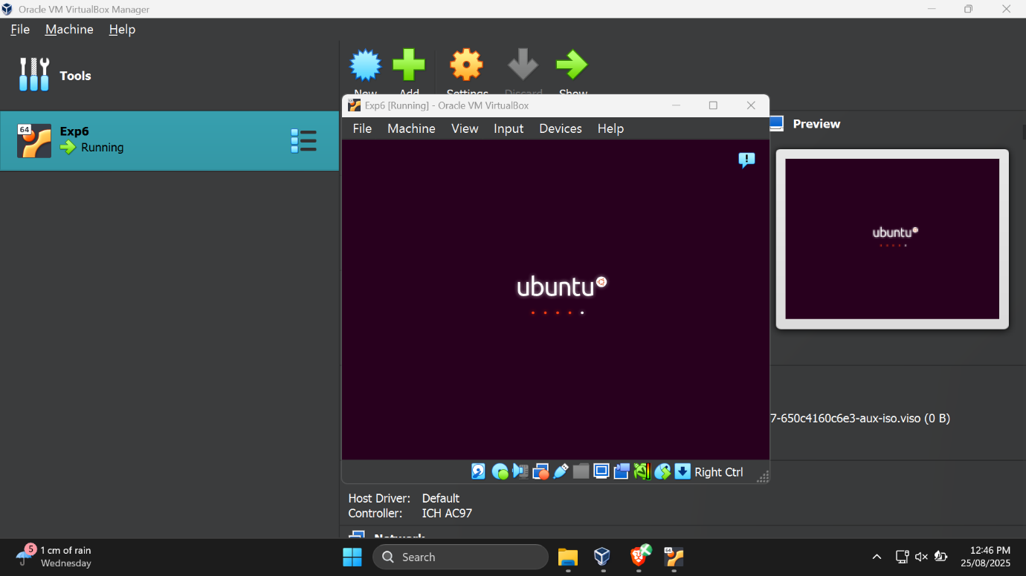

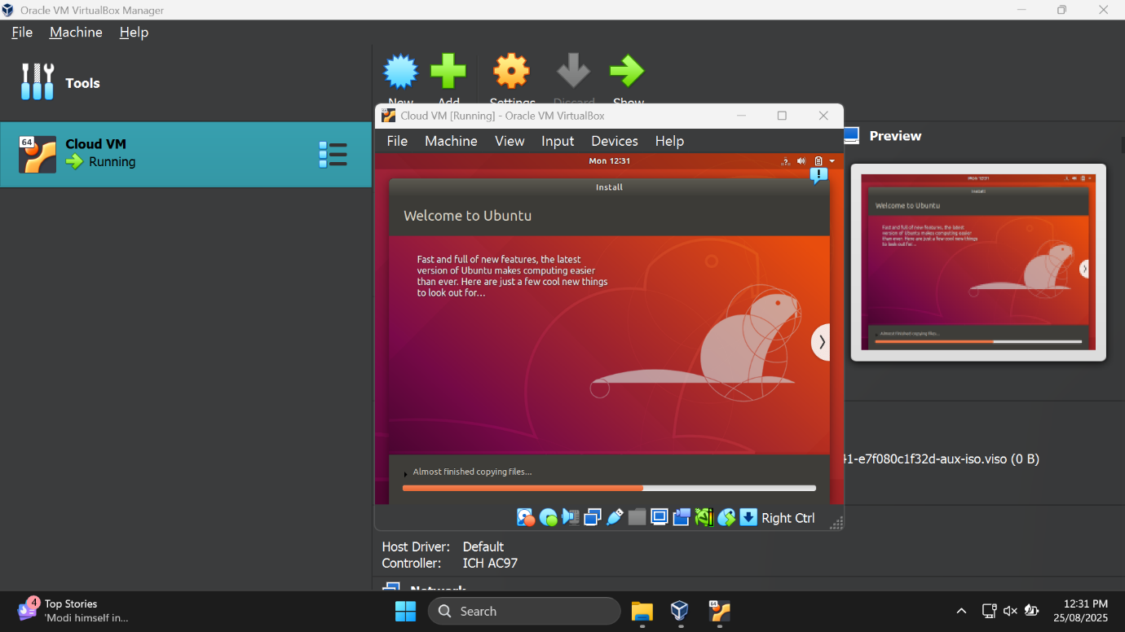

**Result:**

Thus the virtual machine was created and run successfully